5L.2 Assignment(19CSE204)
Name = Ron Jacob Varghese
Class = S3,CSE-D
Roll No = AM.EN.U4CSE19346

Practise Lab Assignment-1
Code:
package net.codejava;
class OverloadDemo {
void test() {
System.out.println("No parameters");
}
// Overload test for one integer parameter.
void test(int a) {
System.out.println("a: " + a);
}
// Overload test for two integer parameters.
void test(int a, int b) {
System.out.println("a and b: " + a + " " + b);
}
// overload test for a double parameter
double test(double a) {
System.out.println("double a: " + a);
return a*a;
}}
public class Driver {
public static void main(String[] args)
{
OverloadDemo ob = new OverloadDemo();
double result;
// call all versions of test()
ob.test();
ob.test(10);
ob.test(10, 20);
result = ob.test(123.25);
System.out.println("Result of ob.test(123.25): " + result);
}
}

Output:
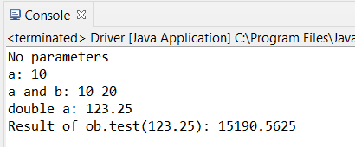
Observation:
The above class consist of four methods of same name but different parameter(ie.overloading)
one method that has no parameters
one method that takes in an integer
one method that takes in two integers
and the other that takes in a double
Practise Lab Assignment-2

Code:
package net.codejava;
class OverloadDemo {
void test() {
System.out.println("No parameters");
}
// Overload test for two integer parameters.
void test(int a, int b) {
System.out.println("a and b: " + a + " " + b);
}
// overload test for a double parameter
void test(double a) {
System.out.println("Inside test(double) a: " + a);
}
}
public class Driver {
public static void main(String[] args) {
OverloadDemo ob = new OverloadDemo();
int i = 88;
ob.test();
ob.test(10, 20);
ob.test(i); // this will invoke test(double)
ob.test(123.2); // this will invoke test(double)
}
}

Output:
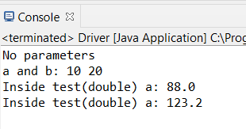

Observation:
the following class is comprised of two methods-
one method takes two integer as parameters
one method takes a double as parameter

